GUI To-Do List
Original Program:
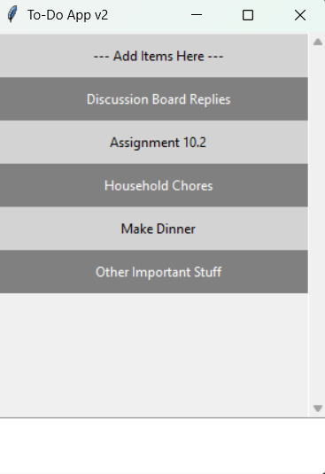

Updated Program:
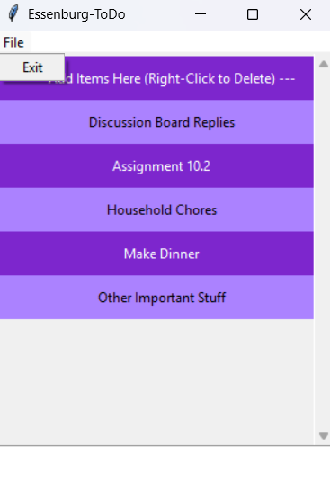

Deleted Initial Item & Assignment 10.2 Item:
